Short Answer / Data Interpretation

Question 25 (12 marks)
In the wake of a drone attack on Saudi oil fields, Australian motorists may feel the impact at the petrol bowser.
By Camille Bianchi (SBS News)

Australian motorists have been warned they won't be immune from the impact of drone strikes on oil fields in Saudi Arabia. The attacks on oil fields owned by supplier Aramco are expected to strip at least five per cent from global oil supplies, with some analysts predicting wholesale barrel prices could increase by 50 per cent. As the Australian market factors in the weekend's events, Scott Phillips, Chief Investment Officer of Motley Fool Australia said consumers should expect price hikes in line with those in other developed markets. "Oil is the most international commodity there is, so to imagine we won't feel a price shock - even due to competition meaning oil can be sold at higher prices elsewhere - does not add up," he said.

- From the extract, identify the expected increase in oil prices. (1 mark)
- A 50 percent increase in oil prices.

- Identify and explain the impact of the increase in oil prices on inflation in Australia. (2 marks)
- leads to cost-push inflation (1m)
- increase in oil prices could translate to higher energy and transport prices which increases cost of production (1m)

- Describe and explain the price elasticity of demand for petrol. (4 marks)
- Def.: the responsiveness of the quantity demanded of a good to changes in its price (1m)
- Establish PED: Demand for petrol would be price inelastic (1m)
- Describe:
- Factor/s affecting PED: Few substitutes/Necessity: may be a necessity for transport and energy generation; also having fewer substitutes, especially in usage for transport (1m) - Qty dd is relatively unresponsive to changes in price (1m)

- Using an appropriate model, demonstrate and explain the likely impact of the drone strikes on the Australian petrol market. (5 marks)
- Diagram: leftward shift of supply curve AND Impact on Price and Quantity (2m)
- Fall in supply in petrol market: Damage to oil producing capacity causes shortage which increases cost of producing petrol. Fall in supply of petrol (1m)
- Impact on P & Q: eqm price increases, eqm quantity falls. (1m)
- Highlight extent of impact on price and qty due to inelastic PED. (1m)

Question 26 (12 marks)

Figure 1. Changes of Gross Domestic Product (GDP) in %

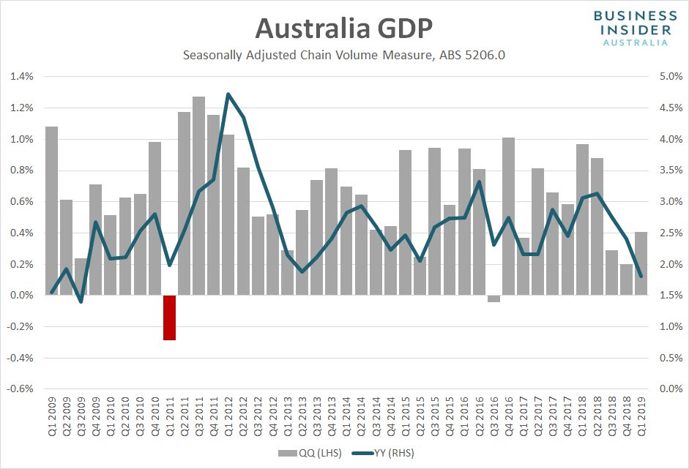

- Explain the term business cycle. (2 mark)
- Highlights periodic fluctuations in the growth of real output (1m)
- consists of alternating periods of expansion (increasing real output) and contraction (decreasing real output). (1m)

- With reference to figure 1, state the trend in the GDP growth rate from 2016 to 2017.
- Unstable / fluctuating? (1m)

- With reference to the GDP growth trend from 2012 to 2013, state and describe the phase of the business trade cycle that would correlate with the stated period. Ensure that you justify your response. (5 marks)
- Identify trend: Falling/decreasing trend (1m)
- Phase: Recession / contraction (1m)
- Description of phase: Following a peak economy begins to experience falling GDP growth, rising unemployment rates, and falling inflation rates. (2m)
- Justification of phase: Data shows growth rates falling (approx. 2%). (1m)
Eg. (end of mining boom)
- Fall in demand for exports (net exports) to China,
- Fall in investment.
- Recession phase: Fall in (X-M) and (I) fall in AE/AD. Fall in Growth.
Decreasing output implies an increase in unemployment rates

- Describe the costs and benefits of economic growth. (4 marks)

Costs (2m)
- Demand pull inflation
- Economic ‘bads’ - e.g. pollution – due to more industrial activity associated with growth
- Labour shortages – Could increase cost of labour (may eventually affect economic growth)
- Increase in crime

Benefits (2m)
- increase real income – improves material SOL(Welfare)
- Increase in taxation revenue to government (improved capacity for public expenditure – more /better public and merit goods – improves welfare)
- More economic opportunities (creates more employment)

Question 27 (12 marks)

Record trade surplus for Australia
DFAT Media release 6 August 2019

Australia’s export sector continues to boom with new data showing Australia recorded its largest ever financial year trade surplus. New data released today from the Australian Bureau of Statistics show that Australia posted a record trade surplus of $49.9 billion for the 2018-19 financial year. “Despite global trade headwinds, Australia’s six largest monthly trade surpluses have all been recorded in 2019, with Australia also now recording 18 consecutive monthly trade surpluses, an achievement that has not occurred since 1972-1973. “However, the impact of global trade tensions and volatility of commodity prices means that there is no room for complacency and there are many threats to be managed.

- From the excerpt, state the trade balance in the 2018-19 financial year. (1 mark)
- A trade surplus of 49.9 billion in the year 2018-2019. (1m)

- With reference to the excerpt, state the two threats to our trade surplus that are mentioned.
- impact of global trade tensions and volatility of commodity prices (1m)

- Describe the trends in Australia’s direction and composition of trade. (2 marks)
- Direction: falling as a net importer and rising as a net exporter (1m)
- Composition: rising trend in the export of goods and services (1m)

- Describe the components of the current account. (4 marks)
- Define Current Account?
- Trade balance - includes value of goods and services that Australian residents export less those that they import. (1m)
- Primary income balance - income that Australian residents earn from, less that they pay to, the rest of the world from working (e.g. wages, rents, interest and profits) and from financial investments (e.g. dividends) (1m)
- Secondary income balance - Consists of two parts:
- income that Australian residents earn from, less that they pay to, the rest of the world from the government (e.g. tax payments and refunds). (1m)
- Current transfers: transactions between Australian residents and the rest of the world where one party provides something to be consumed by another party without receiving anything in return (e.g. emergency food aid). (1m)

- Explain the relationship between Australia’s current account and the capital and financial account. (4 marks)
- The KFA may offset changes in CA and vice versa
- Australia: resource rich country, requires investment to extract resources. (high foreign investment inflows). (1m)
E.g.
- Increase in foreign (direct) investment into Australia, recorded as an increase in the KFA (+KFA)
- will result in an outflow in the primary income balance of the current account in the form of greater servicing costs.(-CA)

